Co2 emission

1.How has the total global Co2 emission changed from 1950 to 2020?

The line chart detailing Co2 emission in the world from 1950 to 2020 is as follows.

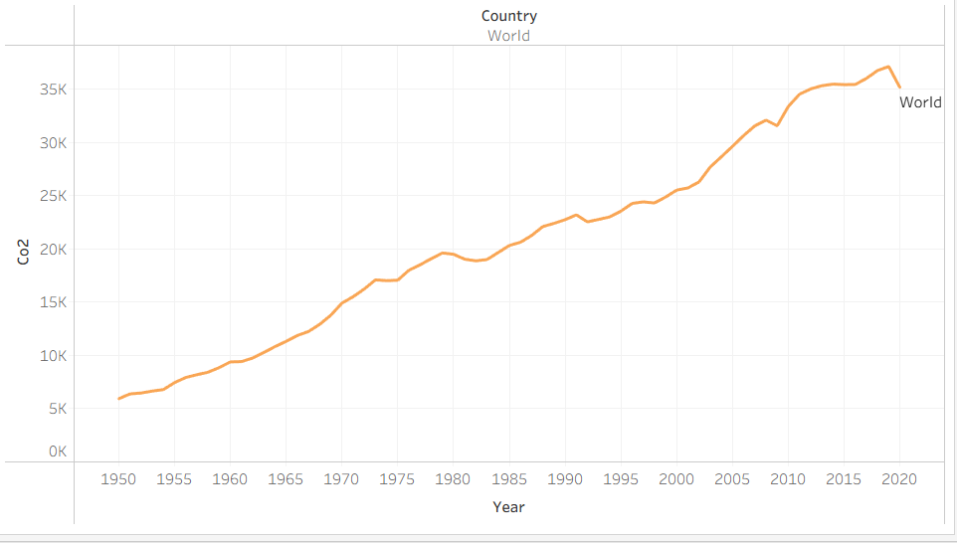

Compare Co2 emissions of India China and USA over time

It clearly shows that Chaina has max Co2 emissions till 2023.

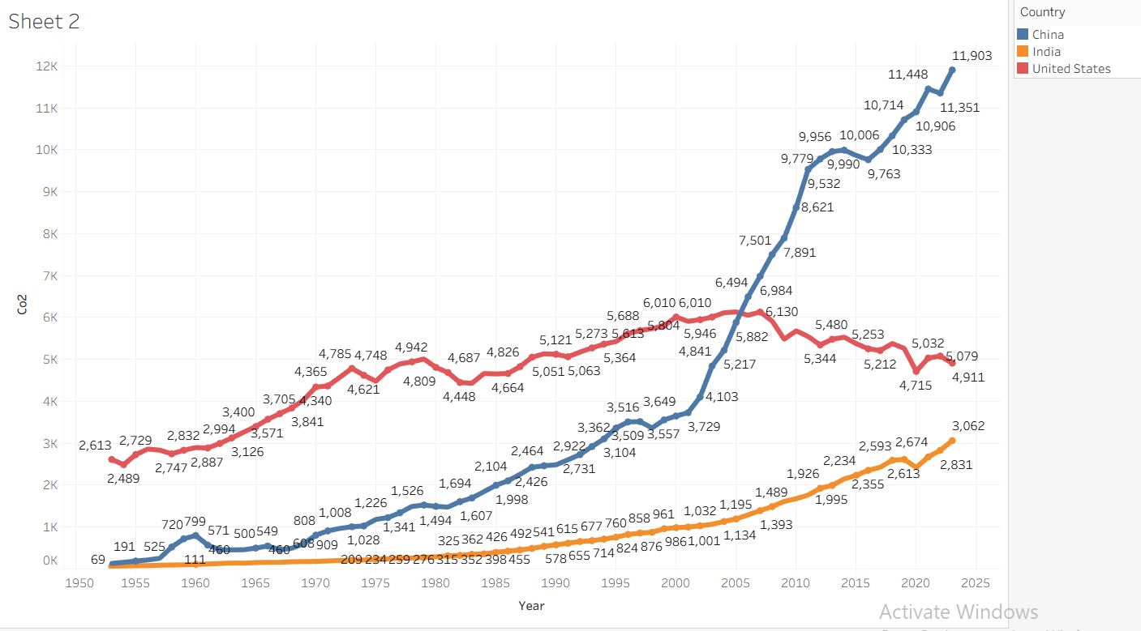

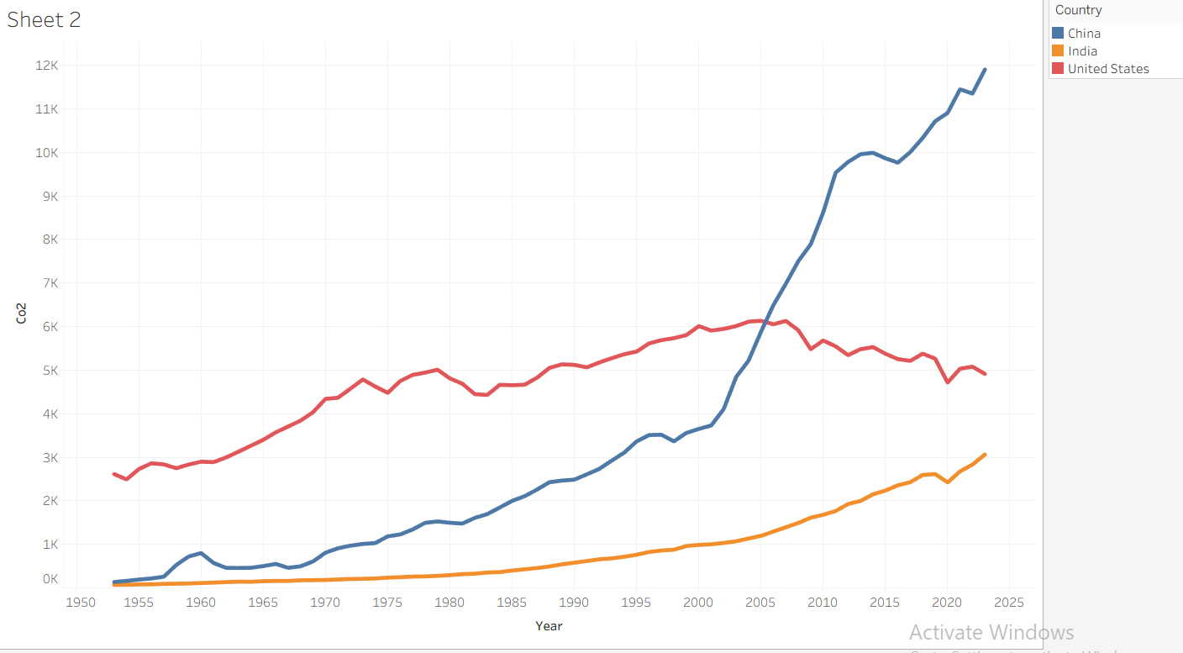

Which countries had the highest CO2 emissions per capita in 2020?

Top 10 countries with per capita Co2 emission is

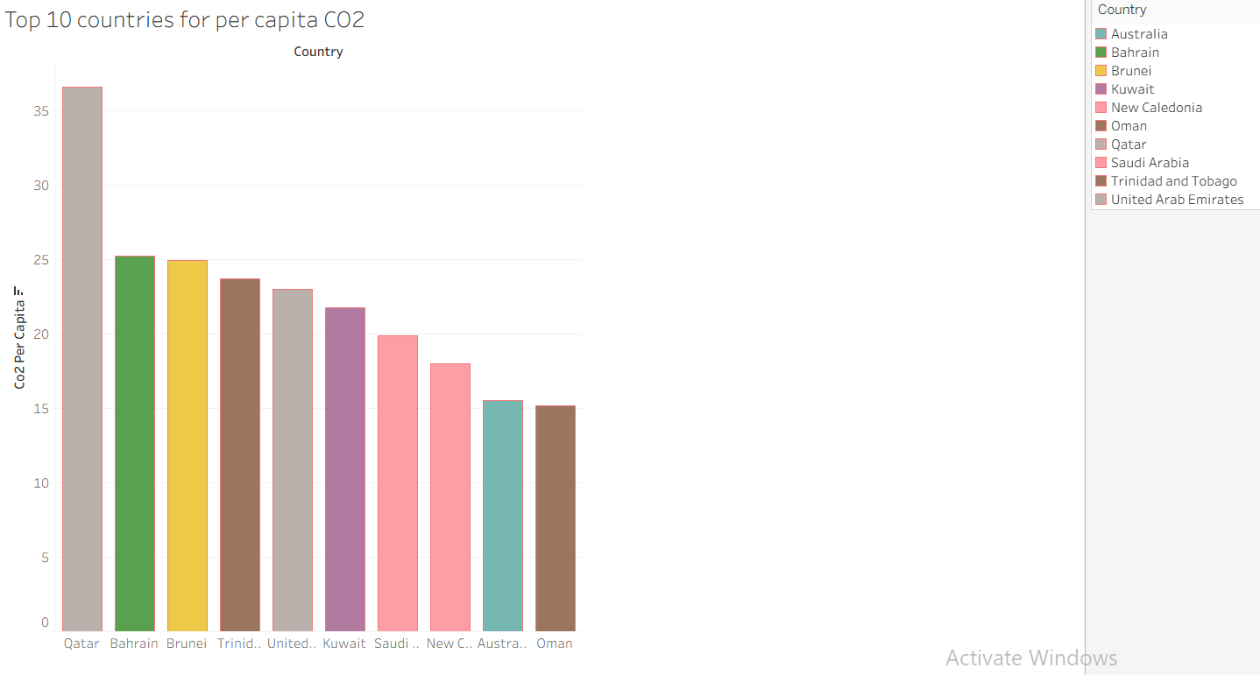T

How do CO2 emissions vary geographically.